UI UX
DOMAIN : Airline Websites
WEBSITES :

Emirates Air India
NAME: Ayush Patil
PRN: 1262243746
ROLL NO: 36
PANEL: F
Emirates: www.emirates.com
Air India: www.airindia.com
PROBLEM STATEMENT-
Critical Analysis of Interfaces: Analyse any one interface (website or mobile app) that you have interacted with that could be designed better. Focus on the interface design problems, rather than their engineering faults or business problems. Comment on its learnability, usability, consistency and metaphors.
CHATGPT VERSION
Emirates vs Air India
Parameter | Emirates | Air India
Learnability | Rich homepage can overwhelm first-time users before they reach the booking tools. | New home screen is easier, but the menu still needs exploring.
Usability | Booking is smooth, but managing existing bookings takes extra steps. | Faster booking after the redesign, but payments still lag at times.
Consistency | Strong, uniform branding across web and app. | Newer screens look polished; older ones haven't caught up yet.
Use of Metaphors | Standard travel icons (luggage, boarding pass) used clearly. | “Journey timeline” in My Trips is a strong, intuitive metaphor.
Navigation Structure | Deep menus with weak breadcrumbs; easy to lose track mid-booking. | Menu is better organised, but check-in is still a few taps deep.
Visual Hierarchy | Promo banners compete with the search bar for attention. | Trip info is well placed, but ads still compete for attention.
Accessibility | Good contrast, but some interactive elements lack clear labels. | Reasonable contrast and readability; screen-reader support unclear.
Responsiveness | Works across devices, but mobile still feels desktop-heavy in places. | App performs consistently across devices; website feels less refined.
Efficiency of Interaction | Core booking is quick, but add-ons and upgrades take extra clicks. | Booking and check-in are quicker now, but payments add friction.
Feedback & System Status | Clear loading indicators and confirmations at checkout. | Weak point — unclear status during payments and points redemption.
Error Prevention & Recovery | Vague error messages during multi-passenger bookings. | Chatbot-first support, with no easy path to a human agent.
Aesthetic & Minimalist Design | Visually appealing but cluttered on smaller screens. | Cleaner and less cluttered than the previous version.
Content Readability | Clean typography, though fare and policy text is dense. | Text and instructions are clear across most screens.
Search & Discoverability | Search works well, but filtering across fare types could be simpler. | Flight search is straightforward, but fewer filters than competitors.
Performance Perception | Feels fast, with smooth transitions between screens. | Inconsistent — home screen feels fast, payment steps feel slow.
Trust & Credibility | Strong brand recognition, visible security cues at checkout. | Strong, backed by recognisable national-carrier branding.
Personalization | Limited — recommendations are generic rather than behaviour-based. | Improving — home screen shows contextual trip info, but recommendations are still basic.
User Satisfaction | Generally high, though frequent users find the booking flow more complex than needed. | Mixed — praised for the redesign, but recent reviews flag payment reliability.

LEARNABILITY
How quickly a new user understands the interface.
Airline | Rating | Points
Emirates | 9/10 | - Feels obvious where to click first — search flights just sits right there.  - Nice that it doesn't bombard you with fields, keeps things breezy for a first-timer.  - Only one promo banner, so it doesn't feel like clutter before you even start.
Air India | 7.5/10 | - A bit more to take in before you get to searching — extra fields, extra banner up top.  - Once you get used to it, the tabs feel just as easy as Emirates.  - The deals and offers section below makes the page feel busier for a new user.

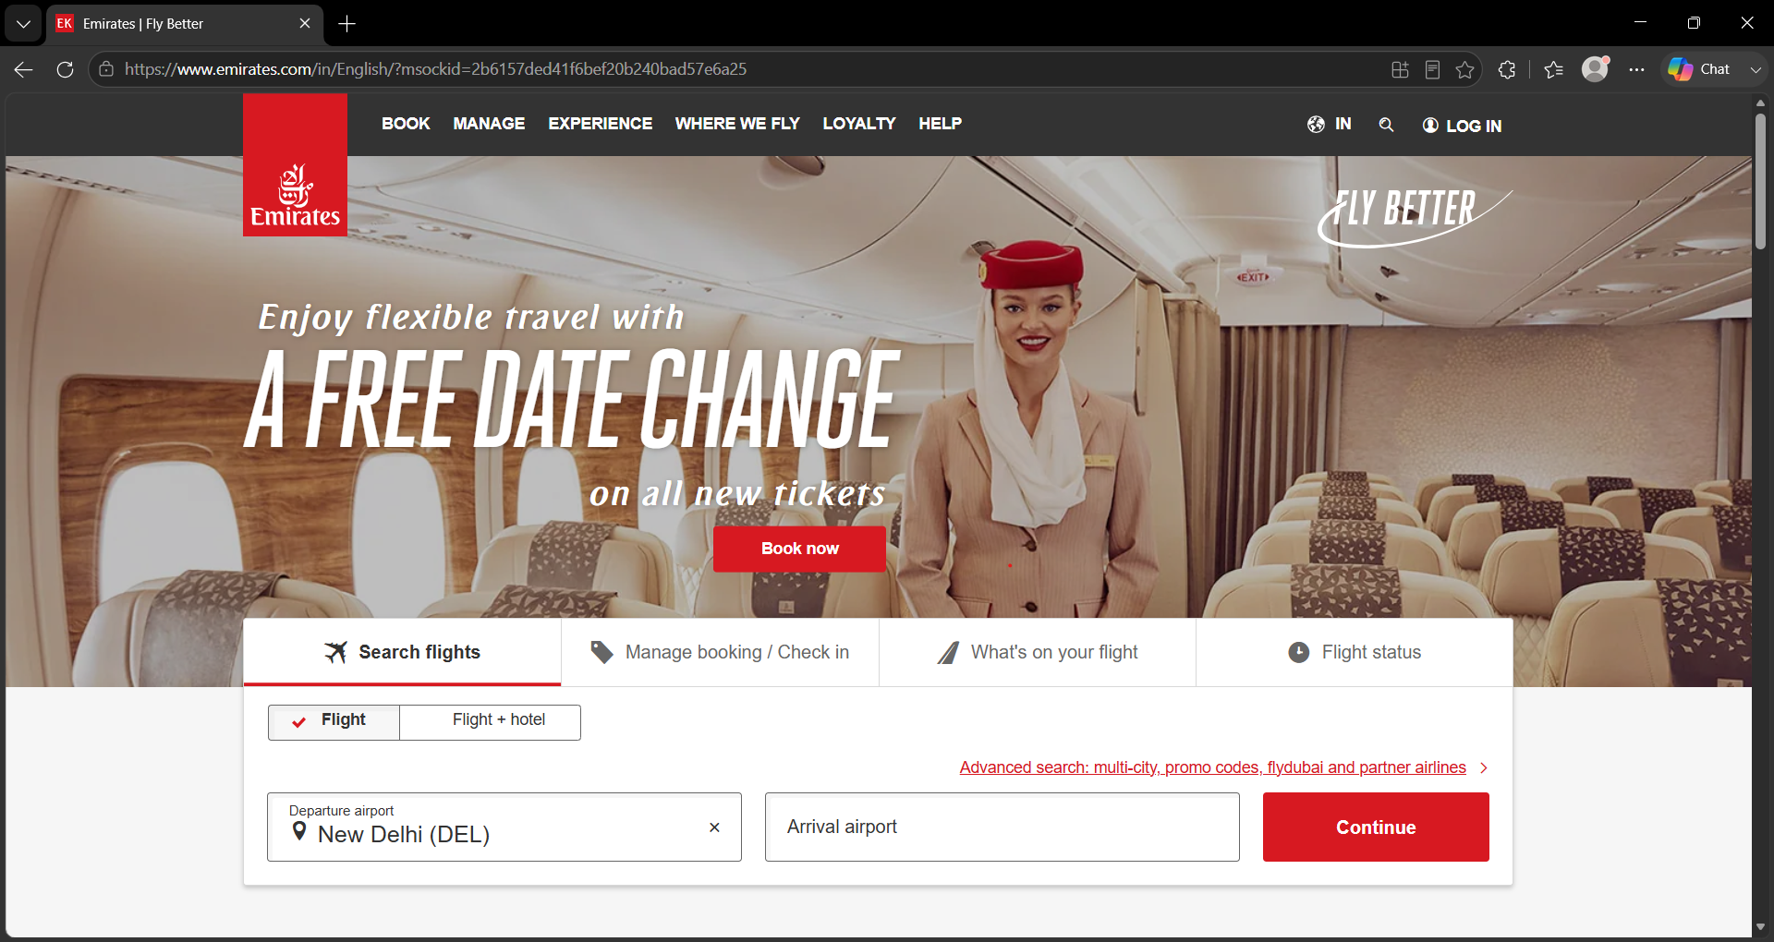  Emirates | 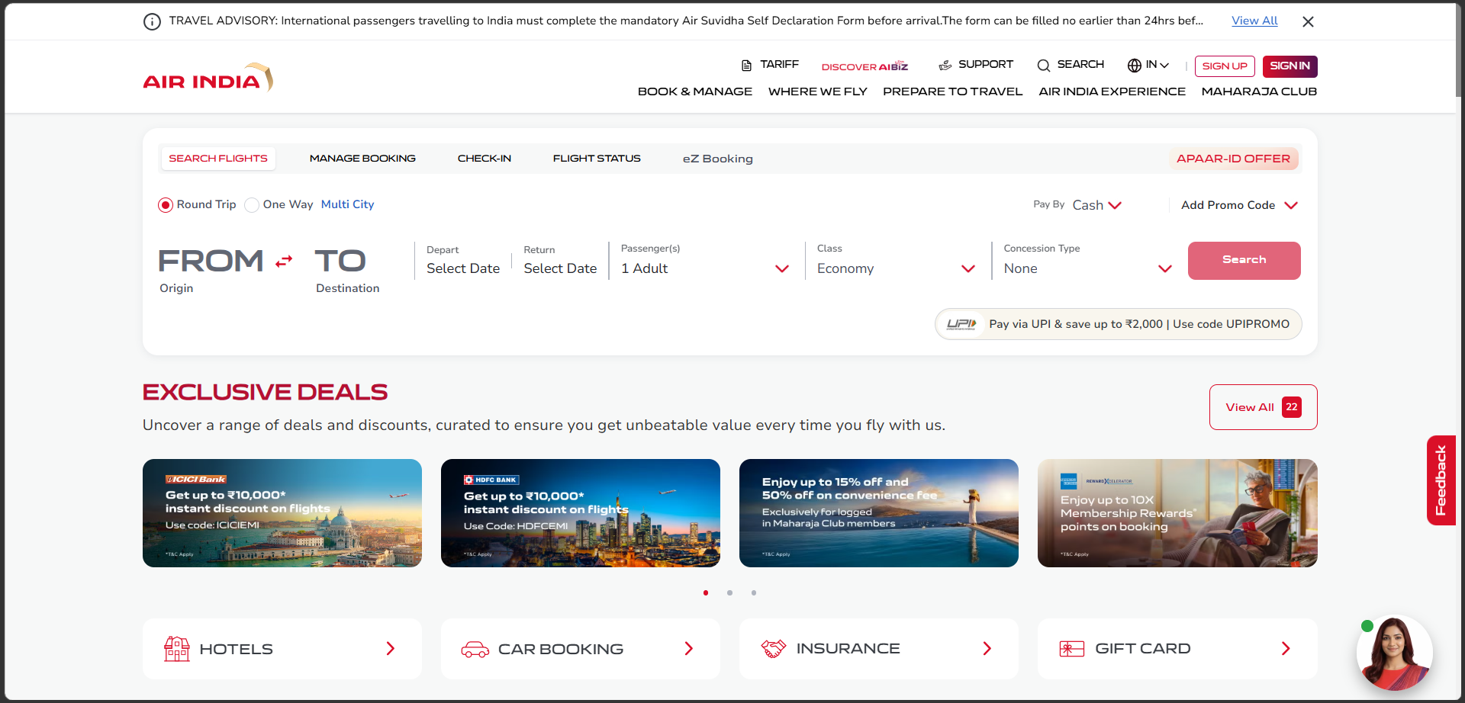  Air India

USABILITY
The ease with which users can complete travel-related tasks efficiently.
Airline | Rating | Points
Emirates | 9/10 | - Manage booking and check-in sit right next to each other, so switching tasks feels effortless.  - Just last name and booking reference needed — no extra clutter to fill in.  - Two clear buttons (Manage booking, Check in) make the next step obvious.
Air India | 8.5/10 | - Flight number and date is all it asks for — quick and to the point.  - “Show Flights” button stands out clearly, no confusion on what to tap next.  - Slightly more tabs up top (eZ Booking, APAAR-ID offer) which adds a touch more to scan through first.

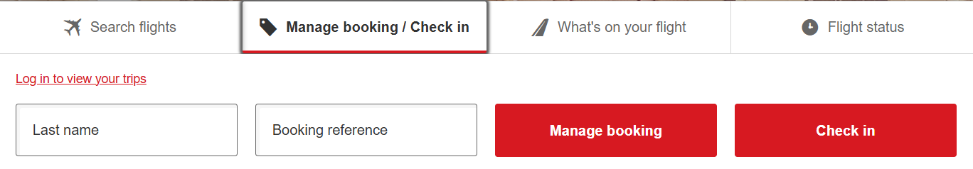  Emirates | 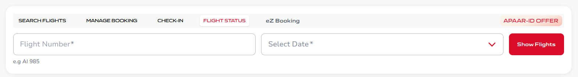  Air India

ERROR PREVENTION AND RECOVERY
How well the interface helps users avoid mistakes and recover from them.
Airline | Rating | Points
Emirates | 9.5/10 | - Help section is neatly split into categories, so fixing an issue doesn't feel like a maze.  - Options like “Changing or cancelling” and “Feedback and complaints” are right there when something goes wrong.  - Search flights stays visible even on the help page, so you're never stuck.
Air India | 7.5/10 | - FAQ page covers a lot of ground, but it's more of a directory than direct help.  - Booking, check-in, and refunds are all there, just takes a bit more digging to find the exact fix.  - Feedback tab is tucked to the side rather than upfront like Emirates.

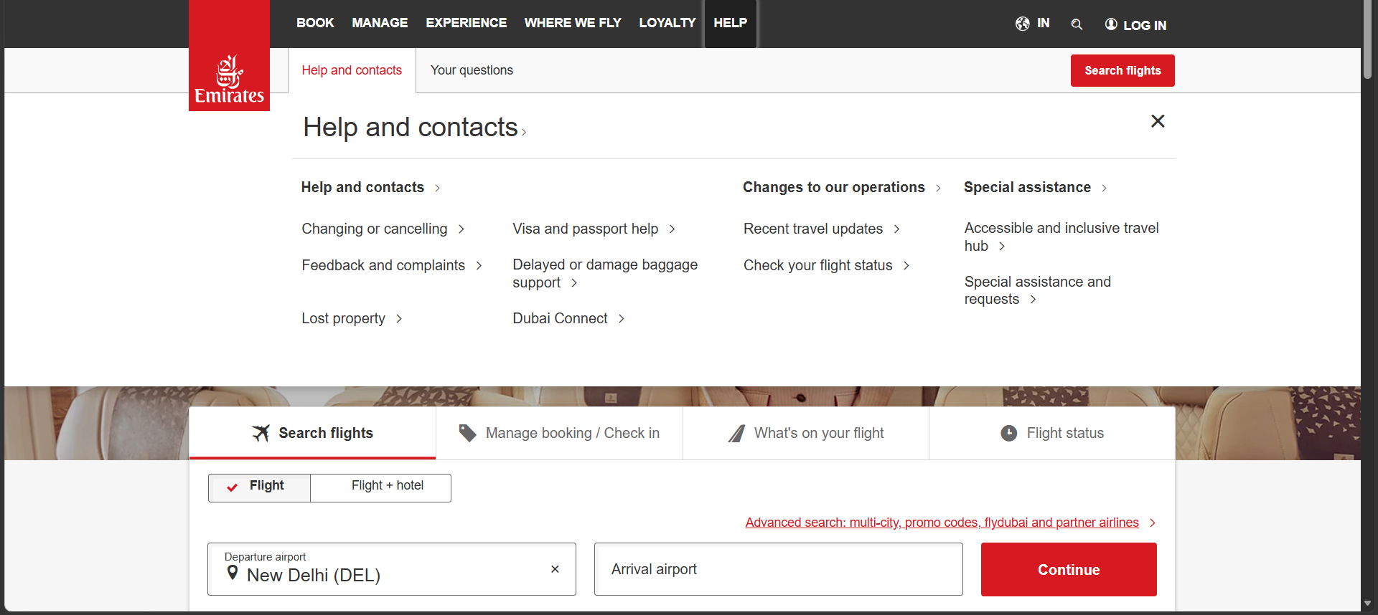  Emirates | 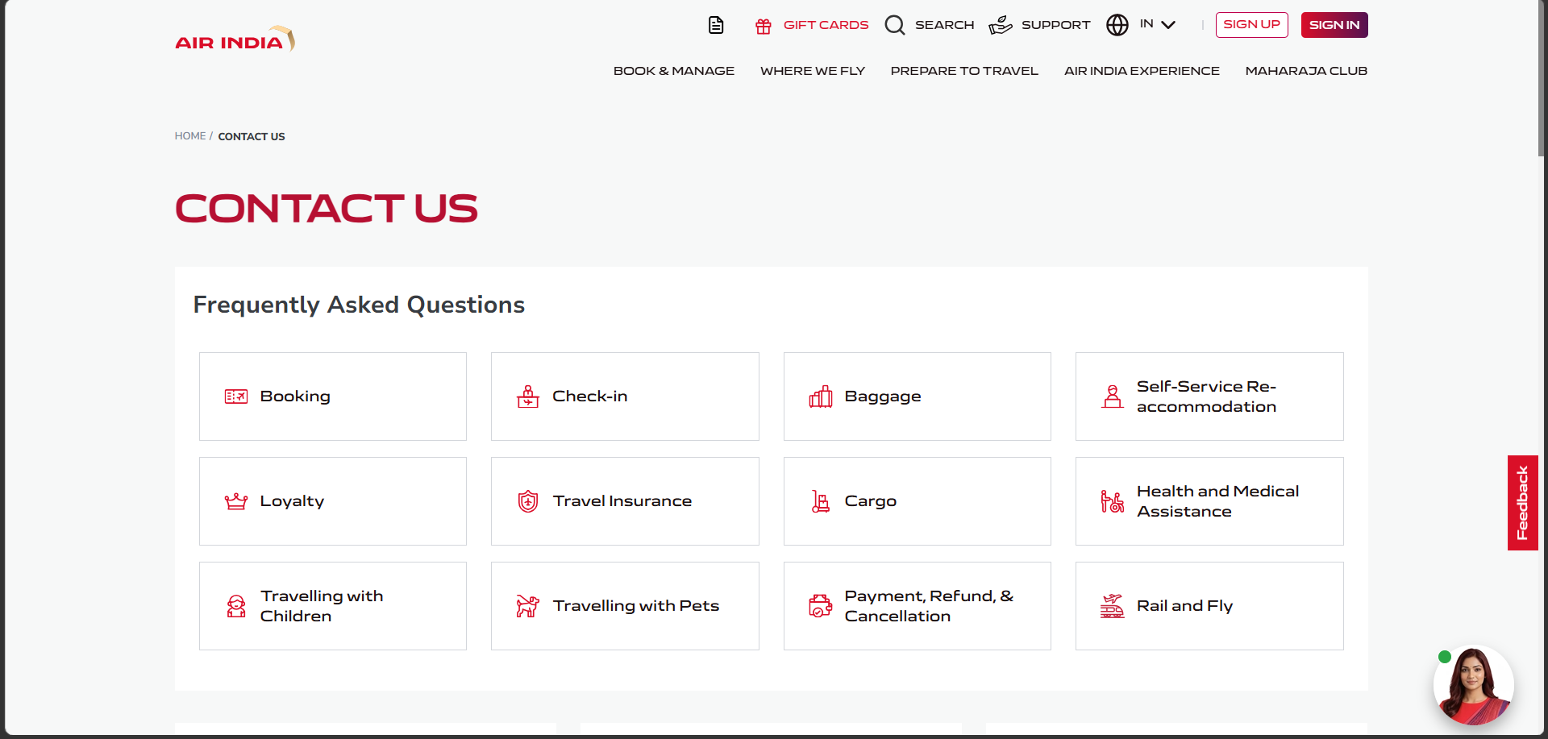  Air India

USE OF METAPHORS
Using familiar real-world icons and symbols to help users understand and navigate the interface easily.
Airline | Rating | Points
Emirates | 8.5/10 | - Icons for hotels, car rentals, tours feel instantly recognizable — no guessing needed.  - Chauffeur-drive and Meet & Greet icons use familiar handshake and car visuals that map well to real life.  - Just one icon (chauffeur) feels slightly less obvious than the rest without a label.
Air India | 8.5/10 | - Hotels, car booking, insurance, gift card icons are simple and easy to read at a glance.  - The handshake icon for insurance is a nice, relatable touch.  - Clean row layout makes each metaphor stand out without crowding the others.

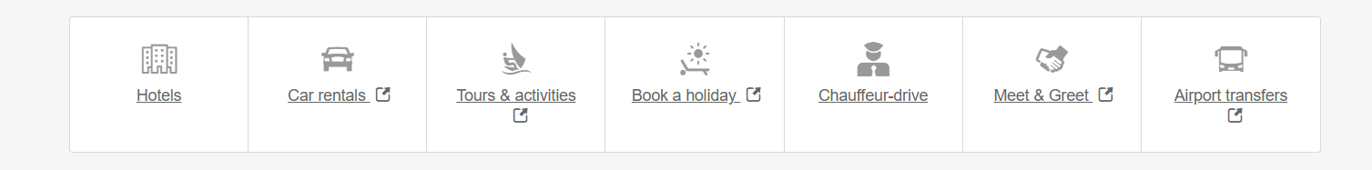  Emirates | Air India

8 GOLDEN RULES OF INTERFACE DESIGN
Golden Rule | Emirates | Air India
1. Strive for consistency | Branding, colours, fonts stay consistent across pages | Newer screens (home, My Trips) consistent; older screens don't fully match yet
2. Seek universal usability | Works well for frequent flyers, overwhelming for first-timers | Redesigned home screen is friendlier for new users than before
3. Offer informative feedback | Clear confirmations and loading indicators at checkout | Weak — unclear status during payments/points redemption
4. Design dialogs to yield closure | Booking ends with a clear confirmation screen | Journey timeline gives clear progress/closure at each trip stage
5. Prevent errors | Weak — vague error messages in multi-passenger bookings | Chatbot-first support gives little guidance on errors
6. Permit easy reversal of actions | Changes/cancellations possible but take several steps | Managing bookings is easier post-redesign
7. Keep users in control | Deep menus can make users feel lost | Better-organised menu gives clearer control
8. Reduce short-term memory load | Promo banners add visual noise | Home screen surfaces trip info directly, reducing digging

THANK YOU!!

